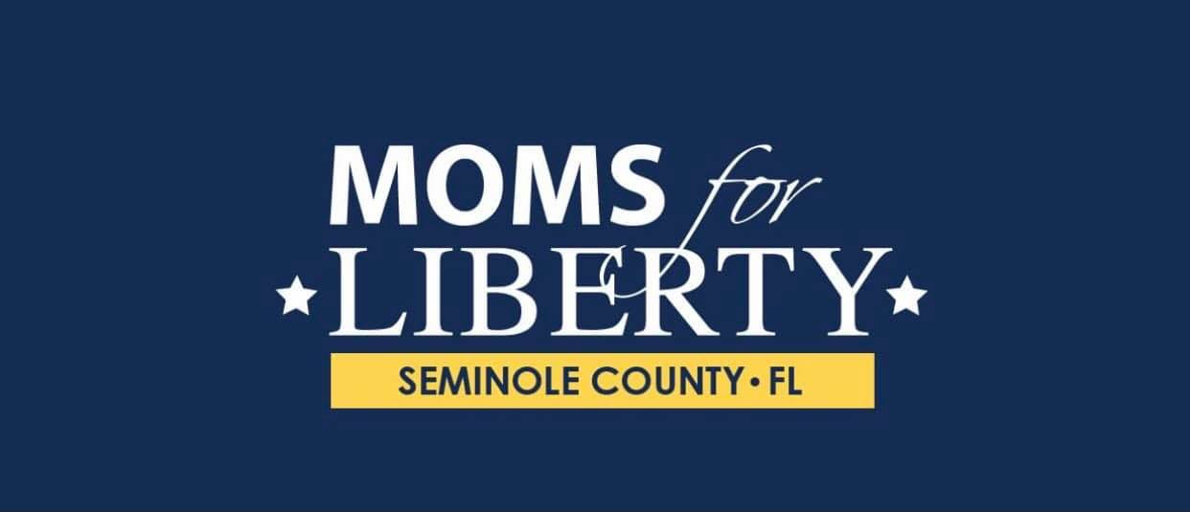
MOMS FOR LIBERTY- Seminole Chapter
Chapter Meeting 2/19/2026 at 4PM
Location-Friendly Confines Lake Mary
Attendees: Pegi Smith, Adela Culler, Leslie Kirschenbaum
Topics Discussed:
March 5th /Chapter Meeting Kickoff Event-Friendly Confines Lake Mary
- March 5th Event venue change. New Location Friendly Confines Lake Mary. Flyers and Social Media updated with new location.
- March 5th event menu planned. Budget to include appetizers and dinner options for 40 people. Any modifications to menu to be provided to Friendly Confines by 2/27/2026. Cash bar for all beverages.
- Discussed Merchandise order-Merchandise needed for March 5th event. Additional Merchandise needed for (2) upcoming community events.
- Budget-discussed projected bank account balance after March 5th event. We agreed sponsorships and fundraising opportunities will need to be pursed as soon as possible.
- Discussed security for event. Chair has made request with the Lake Mary Police Department, for an off duty officer to be in attendance.
- Speakers for event are confirmed. Chair will reach out to confirm what topics will be discussed by speakers and how much time will be needed.
- Agenda meeting- Intro to new leadership, Pledge, Issues chapter plans to take on
( AI implementation in schools, School “walkouts”, Taxpayer funded Charter school for developmentally disabled and autistic children in Seminole county) member expectations, committees within the chapter, speakers.
- Discussed dividing up member list and calling members to personally invite them to March 5th event. Discussed reaching out to local and state reps for personal invites to event

**Still need to designate a monthly chapter meeting day**

Capitol Hill Day March 17th-19th Washington DC

- Discussed Flights Chair and Treasurer planning to travel together.
- Room Reserved 2/20/2026. Waiting for Lisa on further instructions on room.
- Discussed suggested attire as seen on portal.
- Vice Chair has confirmed meeting with Representative Mills and Senator Moody. We are still waiting on a response from Senator Scott

