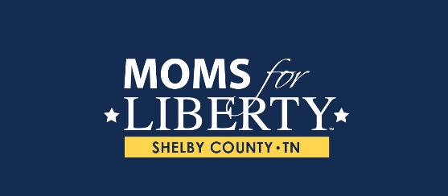

CODE OF CONDUCT

Goal: To establish a set of principles and practices for Moms for Liberty Shelby County, TN members that will set parameters and provide guidance for member conduct and decision-making.

Code: Members of Moms for Liberty Shelby County, TN are committed to observing and promoting the highest standards of ethical conduct in the performance of their responsibilities as members. Moms for Liberty Shelby County, TN members pledge to accept this code as a minimum guideline for ethical conduct. Members shall:

ACCOUNTABILITY

- Faithfully abide by the By-laws and Policies of Moms for Liberty, Inc. and Moms for Liberty Shelby County, TN
- Exercise reasonable care, good faith, and due diligence in organizational affairs.
- Fully disclose, at the earliest opportunity, information that may result in a perceived or actual conflict of interest.
- Fully disclose, at the earliest opportunity, information of fact that would have significance in Moms for Liberty Shelby County, TN leadership’s decision making.
- Remain accountable for prudent fiscal management to chapter members, the board, and nonprofit sector, and where applicable, to government and funding bodies.
- Refrain from entering into a business agreement or contract on behalf of Moms for Liberty Shelby County, TN.

EXCELLENCE

- Maintain a professional level of courtesy, respect, and objectivity.
- Assist other members in upholding this Code of Conduct.
- Strive to create a positive and enjoyable experience for yourself, fellow chapter members, and those you work with in the community.
- Be mindful of all communications (e.g., public speaking, emails, print pieces, websites, and social media), as an always-identifiable representative of Moms for Liberty Shelby County, TN. All communications shall remain informational/encouraging (e.g., offensive jokes, cursing, yelling, and negative dialogue shall be avoided).
- Understand that the success of Moms for Liberty Shelby County, TN depends upon volunteers in a variety of roles.
- Understand that Moms for Liberty Shelby County, TN values its member volunteers and works to create resources and committees to support and enhance their involvement. However, volunteers conducting themselves in a manner inconsistent with the mission, or this Code of Conduct, may be removed.

PERSONAL GAIN

- Exercise the powers invested for the good of all members of the organization rather than for his or her personal benefit, or that of an outside group represented.

CONFIDENTIALITY

- Respect the confidentiality of sensitive information known due to membership involvement.
- Use significant effort to protect and maintain confidential information shared with the group for official business (e.g., constituent data).

This volunteer agreement, once signed, will be in effect for as long as the member is in their position.

Member Name: _______________________________________________________________
Member Signature: ____________________________________________________________
Date: _____________________________

