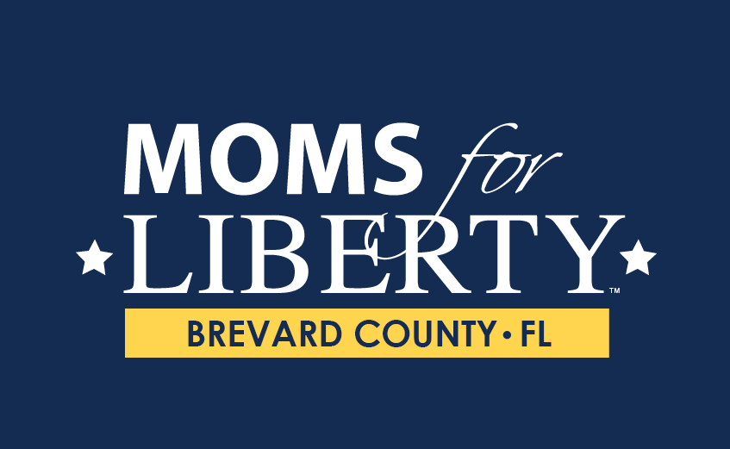

# **Chapter Bylaws**

# **Moms for Liberty - Brevard County, FL**

**Bylaws and Rules of Procedure**

## **Article I: Name & Purpose**

**Section 1** --- Name: The name of this organization shall be Moms for Liberty - Brevard County, FL, a chartered local chapter of Moms for Liberty National.

**Section 2** --- Purpose: The purpose of Moms for Liberty - Brevard County, FL is to protect our children’s education, preserve parental rights, and affect positive change in Brevard County schools.

Goals: The goals of Moms for Liberty - Brevard County, FL are to:

1. To unify, educate and empower Brevard County.
2. To petition, engage, and hold our elected leaders accountable.
3. To elect strong, courageous and liberty-minded school board members.

The Moms for Liberty - Brevard County, FL Chapter is a nonprofit, nonpartisan organization operating within Brevard County, FL, dedicated to promoting the ideals of liberty, individual rights, limited government and parental rights:

1. We hold decision makers accountable or we work to replace them with liberty-minded individuals.
2. We spread awareness and an understanding of the limited role of government.
3. We stand together against government overreach and intimidation tactics.
4. We promote teaching the principles of liberty in our homes and community.
5. We engage our communities and elected leaders on key issues impacting our families.
6. We activate liberty-minded leaders to serve in elected positions.

## **Article II: Membership**

Any person who subscribes to the above values who is a member of Moms for Liberty National and attends Moms for Liberty Chapter meetings in Brevard County, FL may be a member of the Moms for Liberty - Brevard County, FL Chapter.

**Section 1** --- Eligibility for Membership: Moms for Liberty - Brevard County, FL is open to all who:

1) Subscribe to the purpose, goals and values listed in Article 1 section 2;

2) Adheres to the Moms for Liberty - Brevard County, FL Code of Conduct;

3) And is a Brevard County resident;

**Section 2** --- Categories of membership: There shall be two categories of membership: Associate and Regular.

Membership is granted after completion of membership application.

1. Associate membership shall be limited to individuals who apply for membership and who support the mission and values of Moms for Liberty - Brevard County, FL.
2. Regular members will pay annual dues in the amount set by Moms for Liberty - Brevard County, FL Executive Board and are qualified to serve in any official capacity in the Moms for Liberty - Brevard County, FL chapter.

**Section 3** --- Annual Dues: Annual dues will be set by a vote of the Moms for Liberty - Brevard County, FL Executive Board. A portion of each member’s dues is paid to Moms for Liberty National. The Executive Board shall set the anniversary dates for membership dues in conjunction with Moms for Liberty National guidelines. Dues payments received by Moms for Liberty - Brevard County, FL shall be in a fixed amount. No regular membership shall be offered for a period in excess of one year.

**Section 4** --- All contributions or donations may be expended as specified by the Moms for Liberty - Brevard County, FL Executive Board.

**Section 5** --- Any membership may be suspended or revoked by a supermajority (60%+) vote of the Executive Board of Moms for Liberty - Brevard County, FL for just cause after providing one month's notice to the member.

## **Article III: Executive Board**

**Section 1:** The Executive Board of Moms for Liberty - Brevard County, FL , shall consist of at least three Officers of the Moms for Liberty - Brevard County, FL. chapter. Board members shall be regular members of the Moms for Liberty - Brevard County, FL, elected for two-year terms at an annual meeting of Moms for Liberty - Brevard County, FL.

The Moms for Liberty - Brevard County, FL Executive Board shall ensure the effective implementation of these Bylaws, provide for effective communications among members of the Moms for Liberty - Brevard County, FL and the general public, and make arrangements for all Chapter meetings of the Moms for Liberty - Brevard County, FL.

The Officers of Moms for Liberty - Brevard County, FL shall consist of a Chairman/Chairwoman, Vice-Chairman/Chairwoman, and Treasurer, who shall all be voting members of the Board. The Executive Board may also include Secretary, Directors, and other positions as appointed by the Chapter Chair and approved by the executive board.

**Section 2:** Elected Officers shall assume office at the close of the annual meeting at which they are elected. Any officer may be dismissed for misconduct or malfeasance upon one month's notice by a supermajority (60%+) vote of the Executive Board of the Moms for Liberty - Brevard County, FL.

**Section 3:** The Officers shall perform such duties as are prescribed in these Bylaws.

* The Chairman/Chairwoman shall be the primary spokesman of Moms for Liberty - Brevard County, FL; shall execute the resolutions of the Executive Board, shall preside at meetings of the Executive Board, and official sessions of any annual meeting, unless absent or replaced by an acting chairman/chairwoman, and shall ensure the administration of all provisions of these Bylaws.
* The Vice-Chairman/Chairwoman shall assume the duties and obligations of Chairman/Chairwoman in the Chairman’s/Chairwoman’s absence and assist the Chairman/Chairwoman in his/her duties;
* The Secretary shall record and make available the minutes of all meetings, The Secretary shall also ensure that members are provided the opportunity to update their contact information at least once a quarter, credential members for voting, and provide notification to members in all cases in which a rule or bylaw requires notification prior to conducting an action;
* The Treasurer shall be the custodian of all Moms for Liberty - Brevard County, FL funds, safeguard the financial resources of Moms for Liberty - Brevard County, FL and make such periodic reports of finances as the Executive Board of Moms for Liberty - Brevard County, FL and Moms for Liberty National may require. All expenditures of the chapter must be approved by two members of the Executive Board to include the Chair.
* Directors oversee the overall execution of the mission of Moms for Liberty - Brevard County, FL. This can include forming oversight committees, building relationships within the community, and organizing efforts within the chapter.

**Section 3:** The Moms for Liberty - Brevard County, FL Executive Board shall have full power and authority to govern all the affairs of Moms for Liberty - Brevard County, FL between meetings.

**Section 4:** The Moms for Liberty - Brevard County, FL Executive Board shall conduct its meetings in conformance with the most recent edition of *Robert’s Rules of Order Newly Revised* in the absence of standard or special rules it may adopt that conform to these Bylaws and Rules. The Moms for Liberty - Brevard County, FL Executive Board may conduct meetings or ballots by telephone, video conference, or email only when approved by a supermajority (60%+) vote of the Moms for Liberty - Brevard County, FL Board. Regular meetings of the Moms for Liberty - Brevard County, FL Executive Board shall occur at least quarterly, with at least one week’s notice.

**Section 5:** The Moms for Liberty - Brevard County, FL Executive Board will hold a special election in the event that a board member needs to step down from their role, or leaves the organization for whatever reason only if the seat has more than 6 months left in the term. If less than 6 months remain in the term, the Executive Board reserves the right to appoint someone to fill the seat, or leave the seat vacant until the regular election.

A notice to all members will go out and a nomination period of one week will be opened to Regular (paid) Members only. Associate Members will not be able to change their membership in order to run for the position once the notice has been posted.

Anyone interested in the position will have one week from the date of posting to express their interest in the position by writing.

In the event that there is only one person nominated within the deadline, that person will automatically be appointed to the position and serve out the remainder of the current term of the role.

If there is more than one nomination for the role, a special election will be held at the following month's in-person Moms for Liberty - Brevard County, FL meeting after the nomination period has closed. Regular Members in attendance will be given a paper ballot to write in the candidate of their choosing.

Whoever the members elect will then serve on the Moms for Liberty - Brevard County, FL Executive Board for the remainder of that role's term and can run for re-election in their seat's election year.

## **Article IV: Meetings**

The Chapter shall be bound by the Moms for Liberty National bylaws and policy.

**Section 1:** Membership Meetings. The chapter shall hold at least 8 membership meetings each year.

**Section 2:** Executive Board Meetings. The Executive Board meetings of the Moms for Liberty - Brevard County, FL chapter shall be held as needed to be set by the Moms for Liberty - Brevard County, FL Executive Board.

**Section 3:** Annual Meetings. One membership meeting shall be the annual meeting at which the election of the Executive Board shall take place. All voting members must receive at least 14 days’ notice of the annual meeting at which elections will be held.

**Section 4:** Special Meetings. Special Meetings may be called by the Chairman or by the Executive Board.

## **Article V: Chapters**

**Section 1:** Chapters which engage in public outreach or communications shall use standard authorized Moms for Liberty materials including, but not limited to, printed and online publications; unless they submit any new materials or representations of Moms for Liberty to the Moms for Liberty Inc. Executive Board for advance approval.

## **Article VI: Parliamentary Authority**

**Section 1:** The rules contained in the current edition of *Roberts Rules of Order Newly Revised* shall govern the Moms for Liberty - Brevard County, FL in all cases to which they are applicable and which are not inconsistent with these bylaws and any special rules of order Moms for Liberty - Brevard County, FL may adopt. The Chapter Chair may appoint a Parliamentarian to ensure rules are followed.

## **Article VII: Amendment**

**Section 1:** These Bylaws may be amended by a two-thirds vote of the regular members at any regular meeting.

**Section 2:** Amendments shall go into effect immediately, unless otherwise dated in the proposed Amendment.

**Section 3:** Moms for Liberty - Brevard County, FL Bylaws may be amended by a two-thirds vote of the Moms for Liberty - Brevard County, FL Chapter, after at least one month's notice. Should Moms for Liberty - Brevard County, FL Bylaws be amended, notice shall be provided to all Regular members along with the approved changes, within 3 business days.

INDEMNIFICATION: Board members shall not be personally liable for actions taken when acting in the capacity of a director or member.

EMERGENCY BYLAWS: The chapter may adopt emergency bylaws that provide procedures for emergency board meetings and the appointment of substitute Executive Board members. Such measures are only effective during emergencies that prevent a quorum of the regular board members from being assembled.

Certification

These bylaws were approved at a meeting of the Executive Board by two-thirds majority Regular Member vote on_______________.

Date Approved - __________

Signed By Executive Board Member______________________________

# 

# 