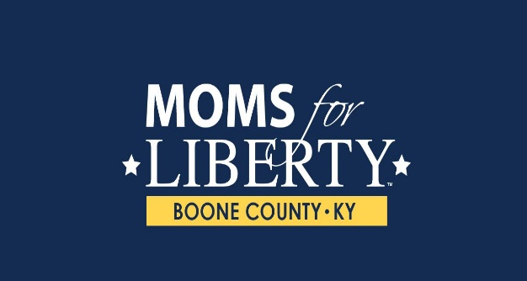

**January 2023 NEWSLETTER**

**Your Leadership:**

**Mirna Eads Karen Strayer**

**Campbell County Chapter Chair Boone County Chapter Chair**

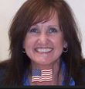

**Wesley Deters Cindy Young**

**Campbell County Co- Chair Boone County Co- Chair**

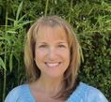

[**www.momsforliberty.org/chapters/campbell-county-ky**](http://www.momsforliberty.org/chapters/campbell-county-ky)

[**www.momsforliberty.org/chapters/boone-county-ky**](http://www.momsforliberty.org/chapters/boone-county-ky)

**Our Email is:** [**moms4libertycampbellky@gmail.com**](mailto:moms4libertycampbellky@gmail.com)

[**moms4libertyboone@yahoo.com**](mailto:moms4libertyboone@yahoo.com)

**You can also find us on Facebook at “Moms for Liberty-Campbell County KY” and “Moms for Liberty- Boone County KY**

**WHAT WE HAVE DONE IN 2022:**

* **August- Started the Campbell County Chapter in Campbell County.**
* **September- Delivered over 2800 pocket Constitutions to every 8th grader in Campbell County and 288 in Boone County.**
* **October- Represented our group at the Supreme Court hearing for School Choice in Shelbyville, KY.**
* **October- Dick Innes with Bluegrass Institute was a guest speaker and did a fantastic eye-opening presentation on our reading levels in schools and the results were alarming.**
* **November- Showed the film “Whose Children are They?”**
* **December- Started submitting Book Challenges to several school districts- Campbell, Fort Thomas and Newport Independent. 22 book challenges to Campbell County Schools, 16 books challenges to Fort Thomas Schools and 17 book challenges to Newport Independent Schools.**
* **December- Started the application process for our Boone County Chapter**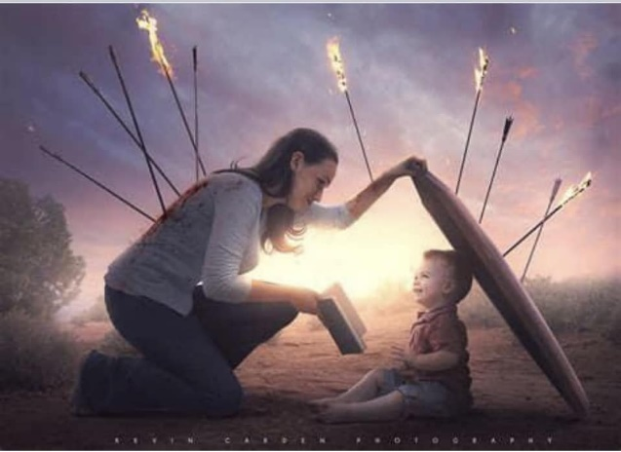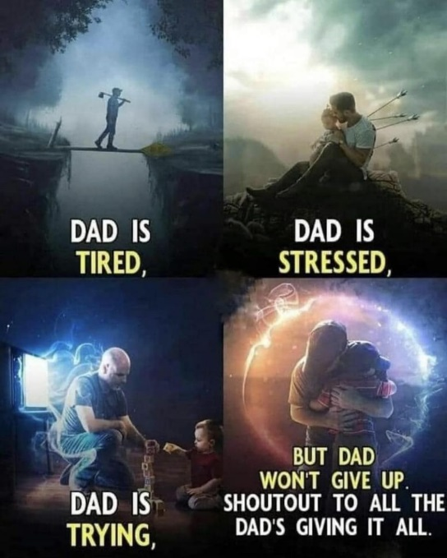

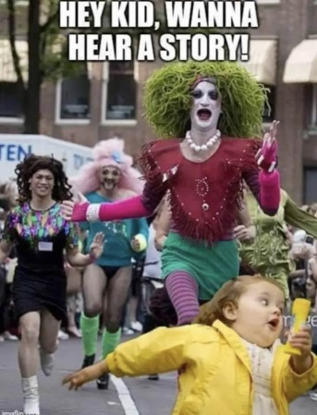

**2023 IS GOING TO BE EXCITING!**



[This Photo](https://www.juku.it/outsourcing-orizzontale-verticale-e-cloud/fireworks-cluster/) by Unknown Author is licensed under [CC BY-SA](https://creativecommons.org/licenses/by-sa/3.0/)

* **We started the Boone County Chapter**
* **We are working on a Kenton County Chapter**
* **And other counties….**
* **We are working on more book challenges**
* **Challenging curriculum containing CRT, SEL, DEI**
* **School board candidate training**

**How can you help?**



[This Photo](https://www.flickr.com/photos/jiposhy/13852413173) by Unknown Author is licensed under [CC BY-SA-NC](https://creativecommons.org/licenses/by-nc-sa/3.0/)

1. **Get involved by joining a chapter**
2. **Attend school board meetings**
3. **Talk to your kids and grandkids-what is going on in their school.**
4. **Talk to their teachers.**
5. **Tell others about Moms for Liberty- we are moms and dads, aunts and uncles, grandparents**

**What have we been up to?**

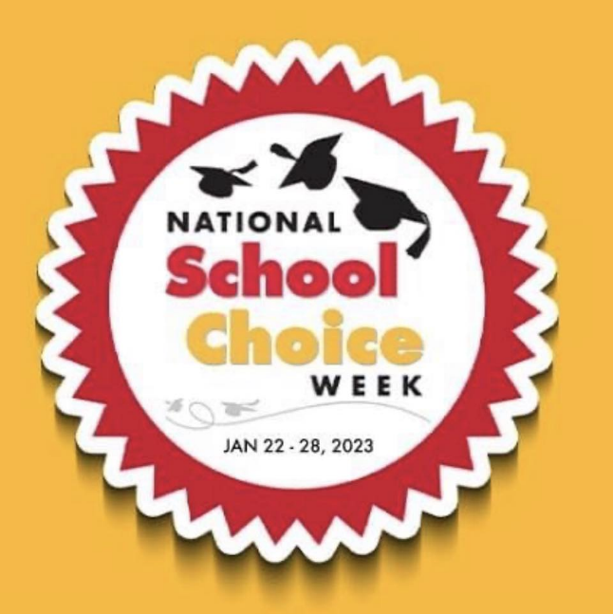 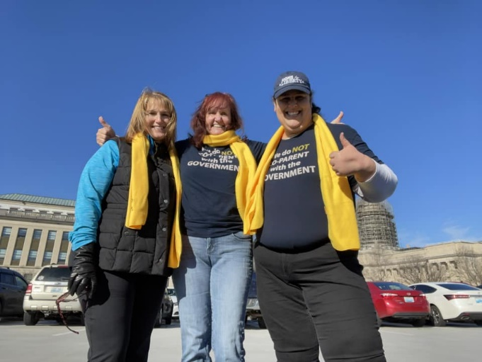

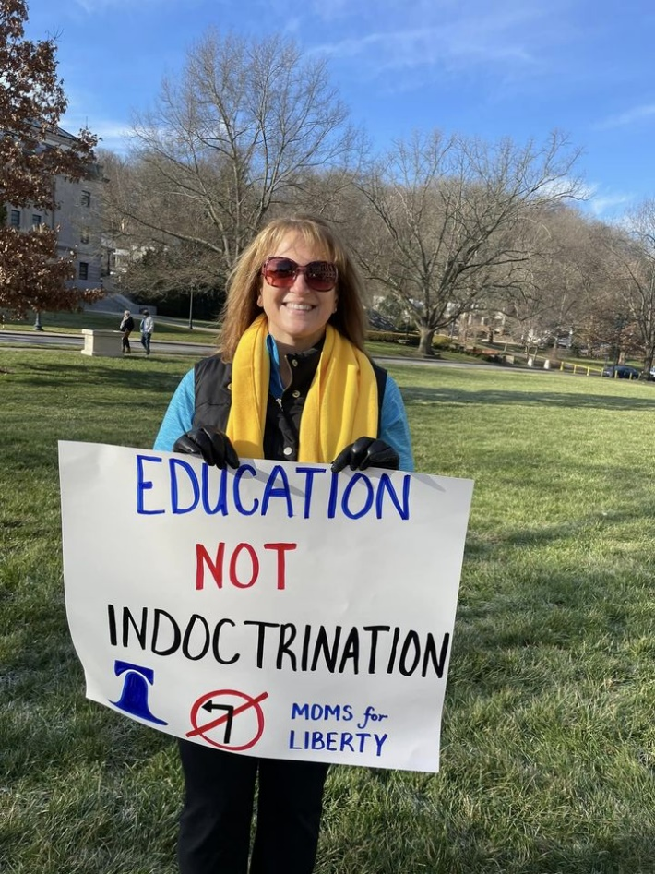 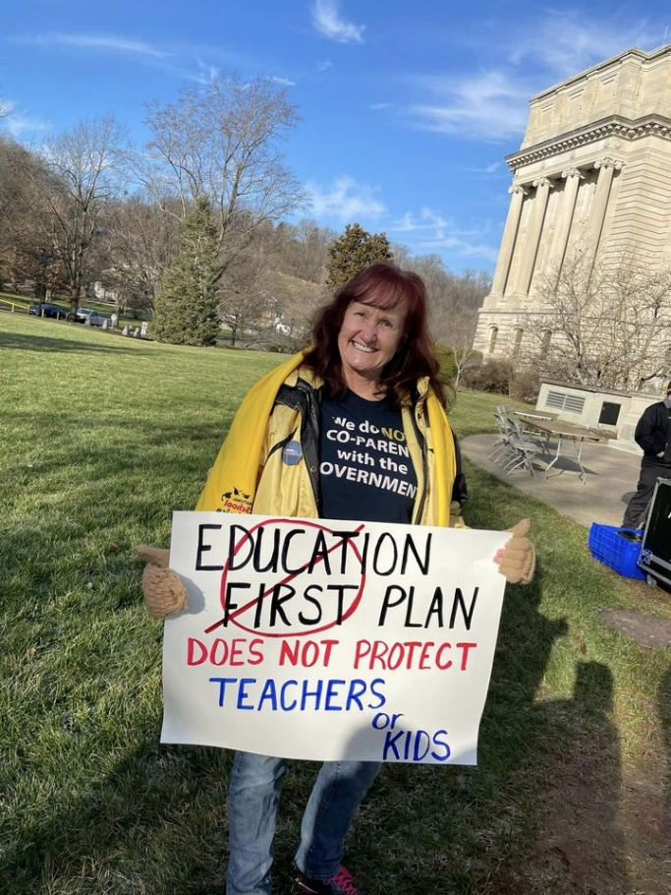



[This Photo](https://politicalclownparade.blogspot.com/2018/11/i-say-disintomation-you-say.html) by Unknown Author is licensed under [CC BY-NC-ND](https://creativecommons.org/licenses/by-nc-nd/3.0/)

**MOMS FOR LIBERTY DOES NOT BAN BOOKS**

**We submit a BOOK CHALLENGE to the school. The school then forms a committee (usually- the principal, the librarian, a teacher and a parent or two).**

**They review the book and decide to 1) Remove, 2) Must have Parental Consent or 3) Retain**

**To date EVERY BOOK THIS CHAPTER HAS CHALLENGED HAS BEEN STRICKLY *PORNOGRAPHIC* IN NATURE. With the exception of Scythe (teens forced to kill others who are of no use to society) and Stamped for kids (which is about racism from a BLM opinion about America’s history)**

**EVENTS COMING UP:**

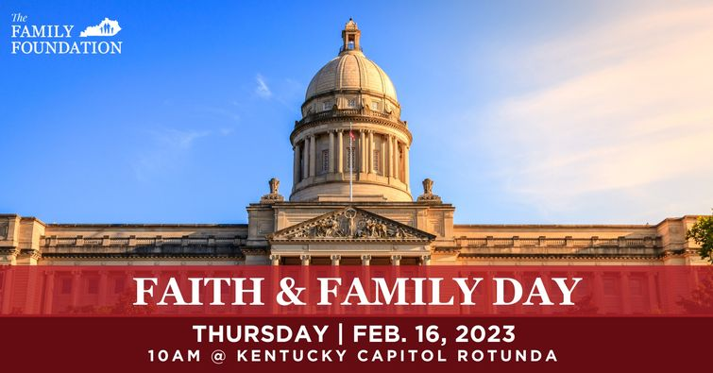

**INFORMATION FAIR COMING IN MARCH- STAY TUNED!**



[This Photo](https://www.stevehargadon.com/2020/09/the-starting-to-homeschool-webinar.html) by Unknown Author is licensed under [CC BY-NC-ND](https://creativecommons.org/licenses/by-nc-nd/3.0/)

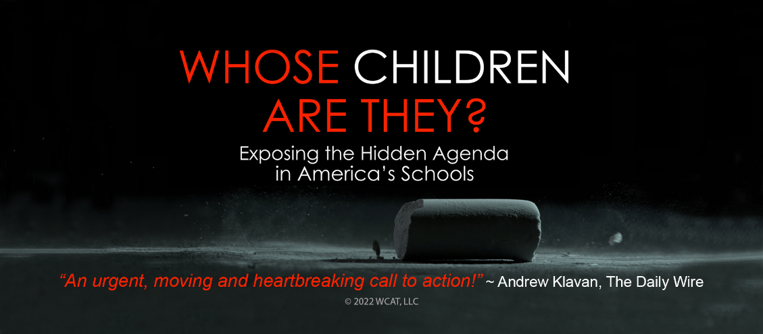

**PUBLIC SHOWING COMING SOON- STAY TUNED**

**MOMS FOR LIBERTY IS TURNING ON THE LIGHTS AND WE NEED MORE CHAPTERS!**

**If you are interested in starting a chapter, contact Mirna Eads and we will TURN ON THE LIGHTS TOGETHER! Each Yellow dot indicates a Moms For Liberty Chapter. Every day a new chapter begins (no pun intended, lol)**

**43 STATES 265 CHAPTERS 100,000+ Members**

**SINCE JANUARY 2021**

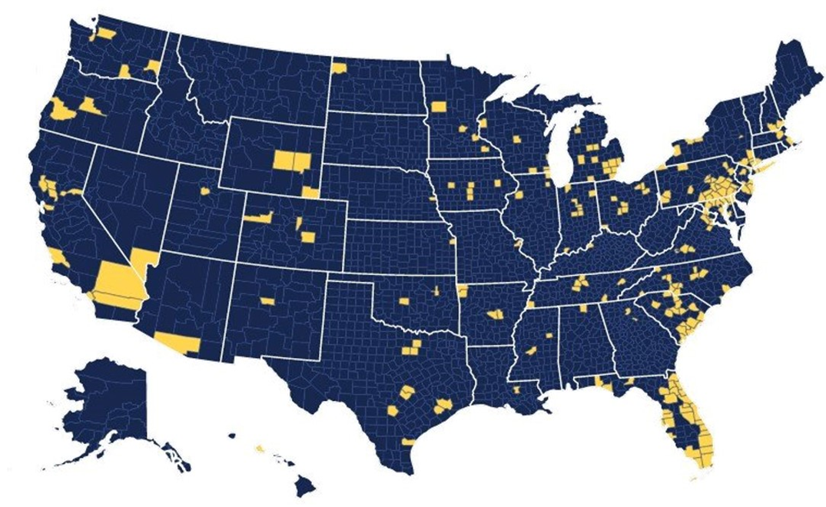

**JOIN OUR CHAPTER TODAY- MEMBERSHIPS: (Non-Voting): $0, (Voting): $25/yr**