**MCPS 2025-2026 Back to School Checklist**

This checklist is intended to serve as a resource for parents, helping them navigate some often-overlooked or unknown policies and actions available to protect and advocate for their children attending MCPS. M4LMoCo exists to unify, educate, and empower parents as the primary decision-makers in raising their children, particularly in matters of education.

* Complete your Annual Notice for Directory Information and Student Privacy. As of August 18, 2025, the 2025 School Year Form is not available online. The 2024 School Year form and information can be found here:

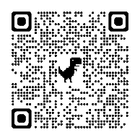

* Familiarize yourself with your rights under PPRA.

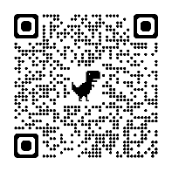

* If you want to opt your child out of any data collection of a protected class, or to inspect aspects of curriculum, contact your child’s principal and teacher(s) in writing. An editable letter template can be found on our website under the Resources Section. (A QR code to our website is on page four)
* Familiarize yourself with Regulation IJA – School Counseling Programs and Service.

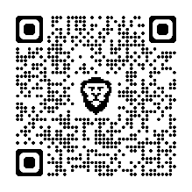

* + If you want to opt your child out of ongoing responsive counseling services without your prior written consent, put it in writing to your child’s principal and counselor(s). This could include opting your children out of SEL lessons.

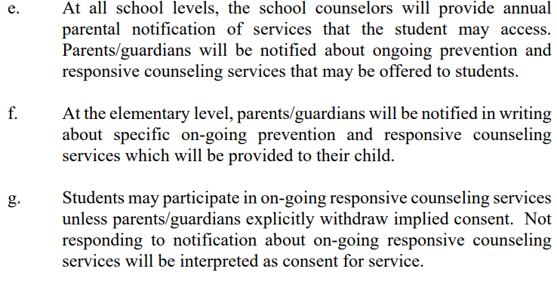

* Familiarize yourself with Regulation IGP-RA – Comprehensive Health Education Instructional Program.

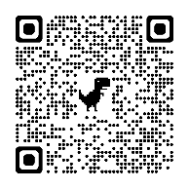

* + Email your child’s principal and inquire about joining the required annual stakeholder group.
  + Email your child’s principal and request copies of the planning group’s annual report.

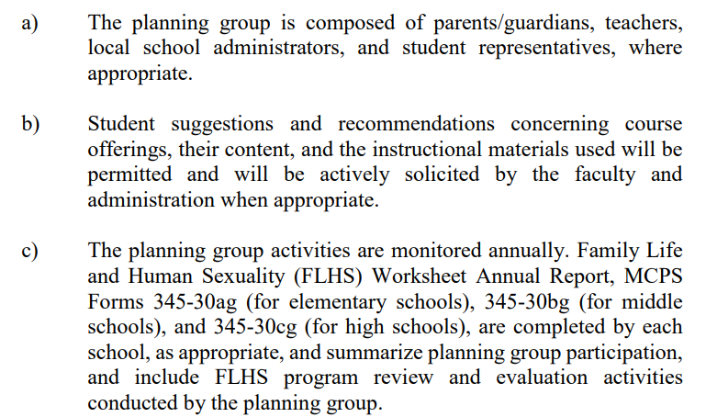

* Familiarize yourself with IIB-RA – Evaluation and Selection of Instructional Materials and Library Books.

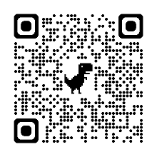

* + If you find that your child is reading a book you disagree with its appropriateness for the school, an editable letter for you to use to start the dialogue with your child’s teacher (and subsequently the principal) can be found under the resources on our website titled MCPS Book Review School Level Step 1

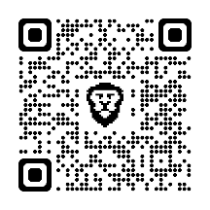

* + If you can’t resolve the issue at the school level, visit our website (using the QR code noted later in this checklist) for a form to submit at the district level, titled: Evaluation and Selection of Instructional Materials, Level 2
* Bookmark and familiarize yourself with the MCPS Database of Accountable Evaluations **(**DAE) Website:

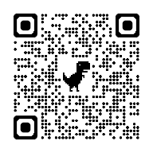

* + Here, you can see all print and media materials approved (or disapproved) in MCPS. An excellent resource for determining if materials are age- or grade-appropriate for your child. If it’s not in the DAE, it’s not approved for use in MCPS.
* Create your child’s MCPS Library Book Reading List through Destiny Discovery (QR code below goes to Destiny Discovery).
  + You need to log-in using your child’s MCPS email and password, but yes, you can choose your favorite books and select which books your child can take from their MCPS library.
  + Once it’s created, email your media specialist and let him or her know that the favorite books are the only ones your child can check out without your permission.
  + Alternatively, you can also have the school’s librarian put an alert on your child’s account to only allow grade-level approved materials to be checked out. Any books above grade level would need your permission.

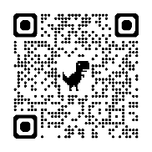

* Bookmark the Lexile Find a Book site and use it to help gauge if your child is reading challenging, grade-level appropriate books, etc.

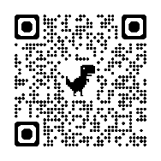

* Download the MCPS 2025-2026 school year calendar, including the Board of Ed calendar.

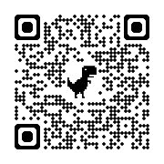

**QR Code to Moms for Liberty MoCo website for all items referenced.**



**While there consider:**

* Become a Moms for Liberty MoCo member to stay up to date & get more involved in parental rights and public education.
* Order a Free Speech Flag Fundraising Kit for an MCPS School near you.
* Remember that we have an anonymous tip line on our website.
* Visit the Moms for Liberty Foundation Page to donate a copy of Libby Justice goes to Williamsburg to a local MCPS Elementary School. It’s been approved for free choice reading!

