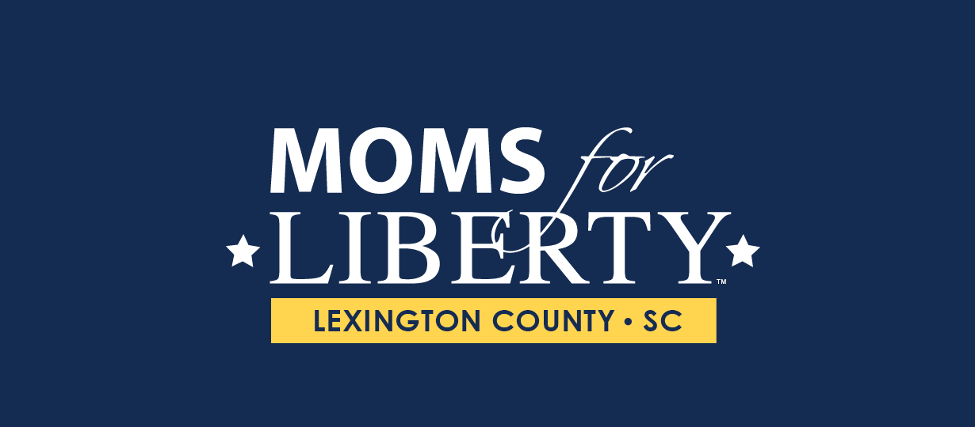

Dear School Board Members,

We ask that the South Carolina Association of School Boards withdraw from and publicly denounce the National School Board Association (NSBA). That includes withdrawing support for and trustees attendance of the NSBA Advocacy Institute scheduled for January 23–25, 2022.

In light of the recent letter sent from the National School Board Association (NSBA) to President Joe Biden on September 29, 2021 asking for "Federal Assistance to Stop Threats and Acts of Violence Against Public Schoolchildren, Public School Board Members, and Other Public School District Officials and Educators" I ask that the South Carolina Association of School Boards follow the lead of Pennsylvania School Board Association (PSBA) and withdraw from the NSBA. In the letter the NSBA has labeled parents attending school board meetings as domestic terrorists. In turn, the United States Attorney General Merrick Garland has directed the Department of Justice (DOJ) and Federal Bureau of Investigation (FBI) get involved with local school boards. This is neither appropriate or justified as local police have jurisdiction and authority to investigate and handle any acts or threats of violence that occur locally. Local school boards are not under the jurisdiction of the DOJ or FBI. This action by the AG is a naked attempt to silence parents that are opposed to the agenda for schools set forth by the extreme left in this country.

Again, we urge the SCSBA to withdraw from and denounce the NSBA.

With Liberty and Justice for All,

Moms For Liberty- Lexington County, SC