**Chapter Meeting**

**Monday, August 5, 2024**

**6:00 pm – 7:30 pm**

**Meeting Agenda**

* **Welcome** **6:00 – 6:05**
  + Prayer –
  + Pledge -
  + Mission -
    - UNIFY
    - EDUCATE
    - 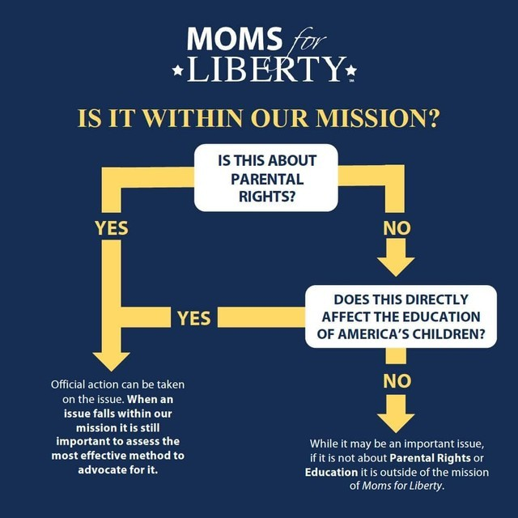EMPOWER
  + Madison Minute – Sandi
* **Introduction 6:05 – 6:10**
  + Chair – Donna Culberson
  + Vice Chair – Jennifer Adams
  + Treasurer – Sandi Touchton
    - Treasurer Report
  + Secretary – Kelly
* **Committees**/**Committee Updates 6:10 – 6:20**

**+++*All Committees need new chairs/coordinators. Please consider volunteering*+++**

* + State Legislative – Donna Culberson
  + Madison Meetups – Sandi Touchton
  + Alternatives to Public Education – Beth Yetzer, Sandy Ward
  + Books – Jennifer Adams
  + Chapter Membership – Jennifer Adams
  + Liaison to BOE – Beth Yetzer
  + Safety – Deb
  + CCPS Meeting Coordinator – Kelly Sengstock
* **Executive Board Positions Elections** **6:20-6:35**
  + Donna Culberson nominated for Chapter Chair
  + Kelly Sengstock nominated for Secretary
* **Title IX – Affects and Injunctions DONNA 6:35 – 7:15**
* **New Things for our Chapter – 7:15 --7:30**
  + Amazon Wish Lists for CCPS Teachers - Jennifer
  + Sept Meeting scheduled for Labor Day – skip or reschedule?

* **Upcoming Events 7:30 – 7:45**
  + MSDE Board Meeting [State Board 2024 Meetings (marylandpublicschools.org)](https://www.marylandpublicschools.org/stateboard/Pages/Meetings-2024.aspx)
    - 8/27
  + CCPS Board Meeting
    - 8/14,5:30pm
    - Please wear ***PURPLE*** in support of Renee Dixon
  + CCPS Citizens Advisory Committee (done for school year)
  + Cecil County Moms For Liberty Chapter Meeting
    - 9/2, 6pm