Chapter Meeting
Monday, August 5, 2024
6:00 pm – 7:30 pm
Meeting Agenda

- Welcome 6:00 – 6:05
  - Prayer –
  - Pledge -
  - Mission -
    - UNIFY
    - EDUCATE
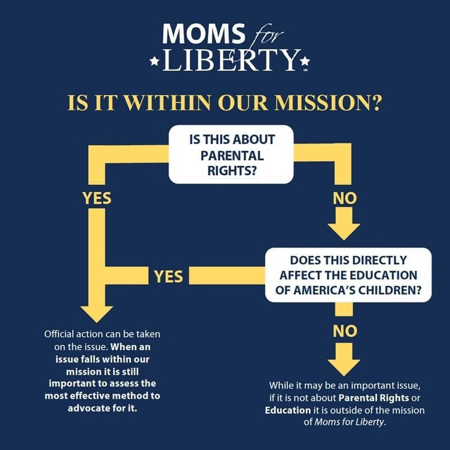
    - EMPOWER
  - Madison Minute – Sandi

- Introduction 6:05 – 6:10
  - Chair – Donna Culberson
  - Vice Chair – Jennifer Adams
  - Treasurer – Sandi Touchton
    - Treasurer Report
  - Secretary – Kelly
- Committees/Committee Updates 6:10 – 6:20
+++All Committees need new chairs/coordinators. Please consider volunteering+++
  - State Legislative – Donna Culberson
  - Madison Meetups – Sandi Touchton
  - Alternatives to Public Education – Beth Yetzer, Sandy Ward
  - Books – Jennifer Adams
  - Chapter Membership – Jennifer Adams
  - Liaison to BOE – Beth Yetzer
  - Safety – Deb
  - CCPS Meeting Coordinator – Kelly Sengstock

- Executive Board Positions Elections 6:20-6:35
  - Donna Culberson nominated for Chapter Chair
  - Kelly Sengstock nominated for Secretary

- Title IX – Affects and Injunctions DONNA 6:35 – 7:15

- New Things for our Chapter – 7:15 --7:30
  - Amazon Wish Lists for CCPS Teachers - Jennifer
  - Sept Meeting scheduled for Labor Day – skip or reschedule?

- Upcoming Events 7:30 – 7:45
  - MSDE Board Meeting State Board 2024 Meetings (marylandpublicschools.org)
    - 8/27
  - CCPS Board Meeting
    - 8/14,5:30pm
    - Please wear PURPLE in support of Renee Dixon
  - CCPS Citizens Advisory Committee (done for school year)
  - Cecil County Moms For Liberty Chapter Meeting
    - 9/2, 6pm

