Lampeter Strasburg High School – Non-Exhaustive List of Sample Inappropriate Books

Sold
http://booklooks.org/data/files/Book%20Looks%20Reports/S/Sold.pdf

Looking for Alaska
http://booklooks.org/data/files/Book%20Looks%20Reports/L/Looking%20For%20Alaska.pdf

Beyond Magenta
http://booklooks.org/data/files/Book%20Looks%20Reports/B/Beyond%20Magenta.pdf

The Glass Castle
- The Glass Castle
http://titlepeek.fsc.follett.com/tp/query?action=3&subnumber=4300235&isbn=074324754X&appid=4
https://www.texanswakeup.com/post-1/book-review-the-glass-castle
https://youtu.be/MgRsqrMC4Lk
"On one of the mattresses, Billy’s father was snoring unevenly. His mouth hung open, and flies were gathered in the stubble of his beard. A wet stain had darkened his pants nearly to his knees. His zipper was undone, and his gross penis dangled to one side. I stared quietly, then asked, “What’s the funny thing?” “Don’t you see?” said Billy, pointing at his dad. “He pissed himself!” Billy started laughing.” Ch. 21, Pg. 262
“Mom, Uncle Stanley is behaving inappropriately,” I said. “Oh, you’re probably imagining it,” she said. “He groped me! And he’s wanking off!” Mom cocked her head and looked concerned. “Poor Stanley,” she said. “He’s so lonely.” “But it was gross!” Mom asked me if I was okay. I shrugged and nodded. “Well, there you go,” she said. She said that sexual assault was a crime of perception. “If you don’t think you’re hurt, then you aren’t,” she said.” Ch. 41, Pg. 582
“Keep this up and people are going to think you’re a nigger lover,” she said.” Ch.32, Pg. 450
(Grandma molests grandchild)...."They’d been gone for a minute or two when I heard Brian weakly protesting. I went into Grandpa’s bedroom and saw Erma kneeling on the floor in front of Brian, grabbing at the crotch of his pants, squeezing and kneading while mumbling to herself and telling Brian to hold still, goddammit. Brian, his cheeks wet with tears, was holding his hands protectively between his legs. “Erma, you leave him alone!” I shouted. Erma, still on her knees, twisted around and glared at me. “Why, you little bitch!” she said. Lori heard the commotion and came running. I told Lori that Erma was touching Brian in a way she ought not to be.” Ch. 33, Pg. 461
"The other girls talked endlessly among themselves about who still had their cherry and how far they would let their boyfriend go." Ch. 46, Pg. 632
PROFANITY COUNT (or other sensitive words to give context)
- f*ck 1
- p*ssy 1
- c*nt 1
- a*s 4
- b*tch 9 (sonofab*itch, etc.)
- b*stard 6
- n*gger 6 (n*ggers, N*ggerville, n*gger lover)
- screw 1
- whore 8
- faggot 1
- rape 3
- drunk 21
- beer 21
- pissed 3
- sh*t 7 (sh*t-hole, bullsh*t, sh*t-for-brains)
- demon 17
- damn 44
- Jesus 2 (in vain, Jesus H. Christ)
- virgin 1
- penis 1
- wanker 2 (also wanking off)
- God 34 (in vain, oh my God, by God, godforsaken, Goddamn, Goddammit)

The Poet X
http://booklooks.org/data/files/Book%20Looks%20Reports/P/The%20Poet%20X.pdf

Two Boys Kissing
http://booklooks.org/data/files/Book%20Looks%20Reports/T/Two%20Boys%20Kissing.pdf

Crank
- Crank
http://titlepeek.fsc.follett.com/tp/query?action=3&subnumber=4300235&isbn=9786074006452&appid=4
https://www1.cbn.com/cbnnews/2021/august/concerned-parents-read-aloud-from-pornographic-books-at-indiana-school-board-meeting
Details a disturbing rape that transpires when a young couple goes into the woods to get drunk and high on meth.
Quotes:
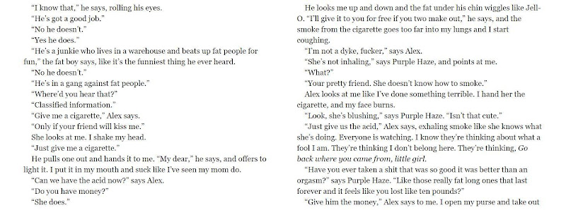

Glass
http://booklooks.org/data/files/Book%20Looks%20Reports/G/Glass.pdf

Mondays not coming
http://booklooks.org/data/files/Book%20Looks%20Reports/M/Monday's%20Not%20Coming.pdf

The female of the species
http://booklooks.org/data/files/Book%20Looks%20Reports/F/The%20Female%20of%20the%20species.pdf

Eleanor and Park
http://booklooks.org/data/files/Book%20Looks%20Reports/E/Eleanor%20and%20Park.pdf

The Black Flamingo
http://booklooks.org/data/files/Book%20Looks%20Reports/B/The%20Black%20Flamingo.pdf

The Kite Runner
http://booklooks.org/data/files/Book%20Looks%20Reports/K/the%20Kite%20Runner.pdf

The Perks of Being a Wallflower
https://www.ratedbooks.org/product-page/the-perks-of-being-a-wallflower-by-stephen-chbosky

The Hate You Give
http://booklooks.org/data/files/Book%20Looks%20Reports/H/The%20Hate%20U%20Give.pdf

The Court of Mist and Fury https://drive.google.com/file/d/1ta1vQHsKIdHx8KJX3uAK17WSNH5vu_8A/view

The Clockwork Princess
http://booklooks.org/data/files/Book%20Looks%20Reports/C/Clockwork%20princess.pdf

