EL Education - CRT, CCS, SEL
“Not knowing the origin of an idea, and the rationale behind it, allows advocates of that idea to hide its history.” –Balint Vazonyi (Hungary)

What is CRT?
CRT analyzes the role of race and racism in perpetuating social disparities between dominant and marginalized racial groups. (DeCuir & Dixson; Ladson-Billings; Ladson-Billings & Tate, 1995)

CRT’s purpose is to unearth what is taken for granted when analyzing race and privilege, as well as the profound patterns of exclusion that exist in U.S. society. (Parker & Villalpando, 2007)

Definitions from the Center for the Study of Social Policy

What is anti-racism?
Active process of identifying and challenging racism, by changing systems, organizational structures, policies and practices, and attitudes, to redistribute power in an equitable manner.

What is equality?
Equality. The effort to treat everyone the same or to ensure that everyone has access to the same opportunities. However, only working to achieve equality ignores historical and structural factors that benefit some social groups and disadvantages other social groups in ways that create differential starting points.

What is diversity?
A synonym for variety. A diversity focus emphasizes “how many of these” we have in the room, organization, etc. Diversity programs and cultural celebrations/education programs are not equivalent to racial justice or inclusion. It is possible to name, acknowledge, and celebrate diversity without doing anything to transform the institutional or structural systems that produce, and maintain, racialized injustices in our communities.

What is equity?
The effort to provide different levels of support based on an individual’s or group’s needs in order to achieve fairness in outcomes. Working to achieve equity acknowledges unequal starting places and the need to correct the imbalance.

What is inclusion?
A state of belonging, when persons of different backgrounds and identities are valued, integrated, and welcomed equitably as decision-makers and collaborators. Inclusion involves people being given the opportunity to grow and feel/know they belong. Diversity efforts alone do not create inclusive environments. Inclusion involves a sense of coming as you are and being accepted, rather than feeling the need to assimilate.
https://cssp.org/wp-content/uploads/2019/09/Key-Equity-Terms-and-Concepts-vol1.pd
Quotes from EL Education
“The current education system is broken—promising limitless possibilities while perpetuating deep inequities. We believe in an anti-racist education that equips every child with the knowledge, skills, and passion to create a more equitable and just world.”
“We embrace a vision of education as a powerful engine for disrupting structural racism.”
“Pillars of educational equity: Explicit anti-racist discussion, practice, and action.
“Anti-racism means taking an explicit stand against racism. We subscribe to author Ibram X. Kendi’s definition: “one either allows racial inequities to persevere, as a racist, or confronts racial inequities, as an anti-racist. There is no in-between safe space of ‘not racist’”.
https://eleducation.org/who-we-are/our-commitment-to-equity-and-antiracism

Educators who are seeking to be anti-racist must understand the nuanced, complex, deliberate design of racism in the United States and across the diaspora. Educators in the United States who are seeking to be anti-racist have to acknowledge and recognize that this country was built upon racist principles. They must be willing to commit to a lifestyle of studying what racism looks like in all its forms.
https://www.learningforjustice.org/magazine/what-antiracism-really-means-for-educators
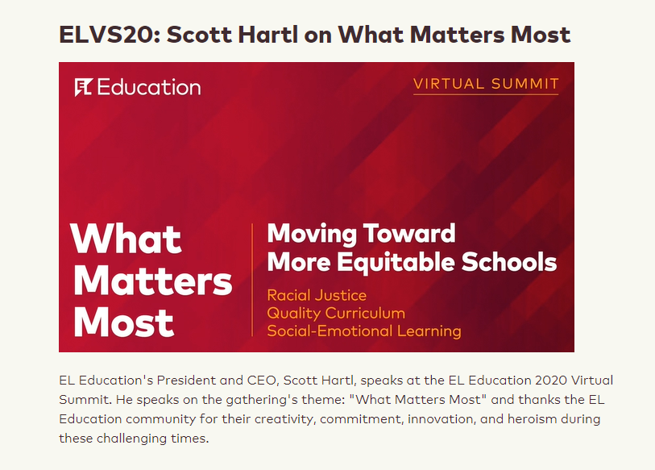

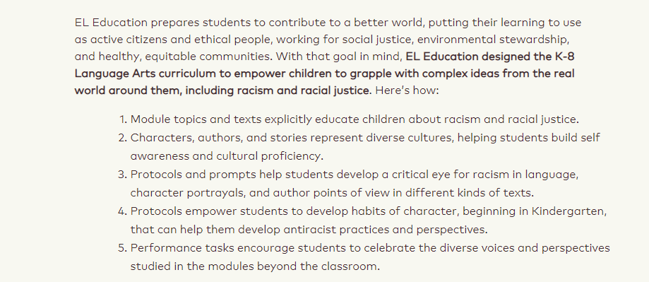
.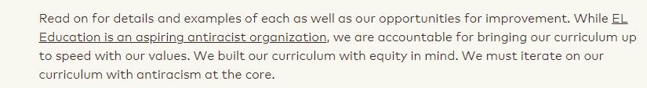
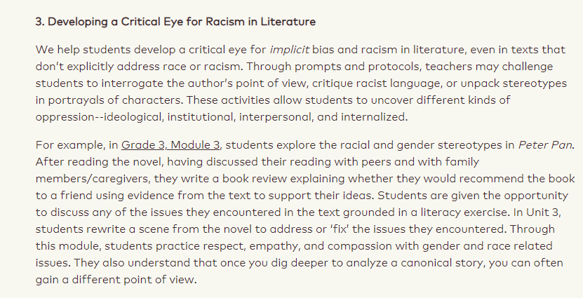

EL Education is Common Core Aligned

“A teacher or principal in any of the public schools of this state shall not use or permit to be used in the person's school, whether as a supplement to the LEA's or school's adopted textbooks and instructional materials or otherwise, textbooks or instructional materials created to align exclusively with the Common Core State Standards.”

https://www.capitol.tn.gov/Bills/112/Bill/SB0769.pdf
https://publications.tnsosfiles.com/acts/112/pub/pc0205.pdf

  - 2012: EL was commissioned to develop a Common Core-aligned ELA curriculum.
  - EL Education initially created the groundbreaking curriculum for New York State’s EngageNY (EL Education website)
  - Recognized as “the highest-quality Common Core-aligned curriculum materials currently available.
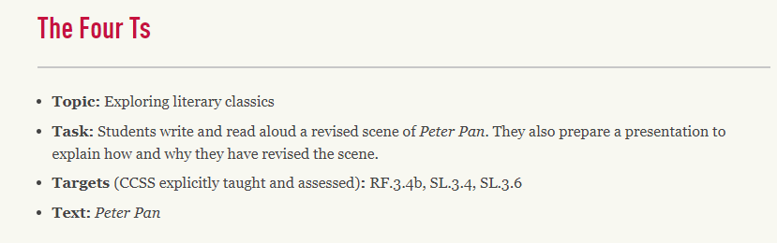

- Fifth Grade EL Education Teacher Manual
P. xvi How does EL Education’s curriculum address Common Core State Standards for ELA/literacy?
El Education’s curriculum was created to teach the Common Core ELA/Literacy standards with a fully content-integrated approach, recognizing as well that the content students acquire is itself a stepping stone to full literacy.

SEL - Only as Dangerous as the Agenda Behind It
ESSER Funds for curriculum must contain SEL?
  - as a transition from knowledge-based education to psychological education.
    - Education was the path to a social and economic revolution; the use of schools was to solve social and political problem
    - The “great task of the school is to counteract and transform those domestic and neighborhood tendencies…the influence of the home and Church.” The home is often an obstacle to proper socialization. (Schools of To-morrow)
    - “…whole child philosophy meant targeting the children’s emotions, feelings, and beliefs as well as their intellect. In practice, what the child believed and felt became more important than what he knew, and schooling became a process of “changing students fixed beliefs.” –Beverly Eakman, Cloning of the American Mind
    - “The special nature of the Soviet education system, which is concerned primarily with character training [social emotional learning], determines the ‘new psychological and didactic approach to the study of the teaching program.’” –Mikhail Heller (former Soviet Union)
    - “…we’ve [Americans] become numb to the signs of creeping socialism….I see it, and I understand it, because I’ve been there….I’ve seen what happens when you’re not allowed to think certain thoughts or say certain things, when your history is rewritten, and when you are taught to genuflect to the ‘right’ ideas and people.” –Jana Kandlova (Czechoslovakia)
    - “Stalin may have killed people, but he used his security forces. Mao, however, turned his own people against each other.” –Xue Xinran (China)

Far Left “Additional Resources” Over a Lifetime of Learning

Once neutral but now far left resources are mentioned throughout all EL Education. UNICEF is a major supporter of comprehensive sex education. Amnesty International has taken a solid Anti-Israel stance among many others in favor of Palestinians. Human Rights Watch stands against a wide variety of border protection measures. Youth Service America recommends Black Lives Matter and Dr. Ibram X. Kendi as anti-racist resources. Here is a quote from the website of Youth Service America:
Recent events have shown that it’s not enough anymore for our policies and practicies to not be racist – we them to be anti-racist. Race Forward, a nonprofit organization that brings systemic analysis and an innovative approach to complex race issues to help people take effective action toward racial equity, defines anti-racism as the work of actively opposing racism by advocating for changes in political, economic, and social life. Dr. Ibram X. Kendi, author of the recent best-selling book How to Be an Anti-Racist defines an antiracist as someone who is expressing an antiracist idea or supporting or an antiracist policy – policies that yield racial equity and ideas that talk about the equality of racial groups.

Curriculum Content Concerns
KINDERGARTEN EL Education Teacher Manual CURRICULUM REVIEW
3/Trees Are Alive | 9781683623441 | Teacher Supporting Materials

Page 23. Living Things Criteria:
- Does it need food?
- Does it need water?
- Does it need air?
- Can it grow or move by itself?
If no, it is nonliving.

Peter Pan - 3rd Grade

Overview of what is taught using this book
Gender and racial stereotypes
EL Education Description and Teacher Talking Points
- Students analyze this book through the lens of the time period it was written, 1904
- This includes an analysis of racial and gender stereotypes, particularly stereotypes of women and native peoples, with the goal of encouraging students to critique familiar and popular stories, rather than not recognizing or ignoring the injustices presented.
- Students will critique the text in a book review and rewrite a scene from the text to right the wrongs
- Consider providing background information and discussion on racial prejudice, women’s rights, and stereotyping
- Ask students to consider how the issues they identify in Peter Pan are still evident today

Concerns
- Children are no longer allowed to just enjoy the story, they are now being told to look for all these issues and then describe how they should be changed.
- Parents would not know this is being discussed because these talking points are not in the book or student worksheets.

Declaration of Independence - 4th Grade

Overview of what is taught
Different perspectives are described from loyalists, to patriots, to Native Americans.

EL Education Description and Teacher Talking Points
- In your own words how would you describe the picture the Declaration of Independence paints of American Indians?
(Response example: Scary people who didn’t care about innocent people)
- From this, what can you infer about the treatment of American Indians after the American Revolution and why?
(Response example: They were probably treated badly, because people thought it was fair to do so as a result of what the Declaration of Independence said.)
Prohibited concept (h) This state or the United States is fundamentally or irredeemably racist or sexist;
- What did Americans believe about American Indians and why?
(Response example: That they had supported the king and cruel treatment as a result of what the Declaration of Independence said.)
Prohibited concept (h) This state or the United States is fundamentally or irredeemably racist or sexist;
- What happened as a result?
(Response example: They weren’t sorry for taking Indian land)

Concerns
- There is no concerning material in the student book, so parents wouldn’t know this is being taught
- In one of the 26 articles of the Declaration of Indepence, the founders stated how the king of England had used American Indians to fight against the colonists. Somehow this has been twisted into the Declaration of Independence saying it’s okay to mistreat American Indians.
The Hope Chest - 4th Grade

Overview of what is taught
Historical Fiction of the events leading up to the ratification of the 19th amendment.

EL Education Description and Teacher Talking Points
- Teacher notes - How can you support your student at home?
- Answer: Research and discuss social justice issues in the United States and in home countries, and how people have taken action and made a difference in support of social justice.
- As students learn about Jim Crow laws, The influenza, and World War 1, they are asked how these things might have affected the lives of Women only. Shouldn’t we be asking how these things affected all people?
- Jim Crow laws: “The laws were made by white people, who felt they were superior, or better, and felt they deserved to be treated better.”
- Inequality is injustice: “The police treat the suffragists as though they are not as intelligent as men.” Ex: “Try to get this through that female wool you call a brain. The female mind isn’t capable of making fine distinctions of logic.”
- “This is inequality and it is unfair.” (Repeated statement throughout lessons)
- Do something Meaningful: “In this book, both Chloe and Violet take risks in order to do something meaningful with their lives.”
- “When people take action against inequality, they can cause social change.”
- As a class, students identify an issue in their community and make a plan for how they will take action - through service, advocacy, or philanthropy.
- Specific, effective learning skills students will focus on:
Take care of and improve our shared spaces and the environment
Apply my learning to help our school, the community, and the environment.

GENDER EQUALITY
- Student Worksheet: Regardless of where you live, gender equality is a human right.
- List examples of things you have the right to do, just as others of the opposite gender do.
- Gender equality is an entitlement or privilege belonging to every single person, everywhere. Everyone is entitled to the same rights and opportunities, no matter what gender they are.
- Youth Guide to the Global Goals: “Gender equality is a precondition for making any serious shift towards a more peaceful, prosperous, and sustainable world.”
- “Denying equal suffrage to women is a terrible injustice.”
- “I would feel _____ about denying women the right to vote.”
- “Denying _____ is a ______ injustice.”

Concerns
- Anti-Family: The main character is an 11 year old girl who seems to despise her parents. She never talks about them fondly. She imagines life without her parents and says “It would be strange. Like a house without a roof.”
- Anti-Men: The men in the book who are not openly for women’s rights are depicted as either alcoholics or men who think women are no better than dirt.
- Feminism: The women who are against the 19th amendment are depicted as tired, flighty, or judgemental. Being a mother or a wife is depicted as oppressive. The main character wants to do something meaningful with her life and the idea of being a wife and a mother makes her feel caged in.
- Anti-American: Although socialism was a part of the suffragist movement, this book glamorizes socialism. Socialism is described as “taking care of each other, not just yourself.”
“Socialists are good Americans. They believe in cooperation instead of competition. Many of the greatest and wisest people in our country are socialists”
- Heavy focus on grooming social activists rather than scholars as the class is instructed to “take action as a class on an issue in their community”.

Quotes from the Book and The Alluded Prohibited Concepts
P. 96 You’ve got it into your head that white folks are going to let me vote?
(b) An individual, by virtue of the individual’s race or sex, is inherently privileged, racist, sexist, or oppressive, whether counsiously or subconsiously
P. 181 Anti’s speal of a Jew legislature: That foreign Jew. He can be made to disappear.
(c) An individual should be discriminated against or receive adverse treatment because of the individual’s race or sex;
P. 147 When women vote there will be no more bribery or corruption. No more war.
(d): A, individual’s moral character is determined by the individual’s race or sex.
P. 20 Socialism, Chloe had once explained to her, meant the idea that people should take care of each other instead of just themselves.
P. 109 Socialists are good Americans. They believe in cooperation instead of competition. Many of the greatest and wisest people in our country are socialists.
Because this book focuses on gender and racism (g) A meritocracy is inherently racist or sexist, or designed by a particular race or sex to oppress members of another race or sex
P. 181 We’re sitting in this Jim Crow car because white people don’t want to have to look at us when they ride on a train.
(k) Ascribing character traits, values, moral or ethical codes, privileges, or beliefs to a race or sex, or to an individual because of the individual’s race or sex;
https://www.wate.com/wp-content/uploads/sites/42/2021/11/0520-12-04.20211108.pdf

Esperanza Rising - 5th Grade
How Were the Human Rights of Characters in Esperanza Rising Threatened?

Anchor chart as demonstrated in the teacher manual:
Description of event and quote from text: | Connections to UDHR | Who? | How were the character’s human rights threatened”
People are not allowed to cross the border into the United States. On Page 83 it says, “Across the tracks, several groups of people were being prodded onto another train headed back to Mexico. ‘My heart aches for those people. They came all this way just to be sent back.” | Article 13 | People trying to cross the border | Article 13 says, “We all have the right to go where we want in our own country and to travel as we wish.” But those people are not being allowed to travel as they wish.
Mama is in the hospital, and it is costing money with no one to pay the medical bills, and Mama isn’t being paid while she is sick. On page 164 it says, “Ever since Mama had first become sick over a month ago, they had no money coming in. The doctor’s bills and medicines had used up most of what they had saved.” | Article 25 | Mama | Article 25 says that “all people have a right to be cared for,” yet no one is paying for her medical bills.
Mexicans and African Americans treated badly because of where they are from and the color of their skin. On Page 187-188 Miguel says, “Americans see us as one big brown group who are only good for labor. | Article 2 | Mexicans and African Americans | Article 2 says, “Don’t discriminate,’ but that is exactly what Miguel says Americans are doing
Prohibited concept (k) ascribing character traits, values, moral or ethical codes, privileges, or beliefs to a race of sex, or to an individual because of the individual’s race or sex.
https://www.wate.com/wp-content/uploads/sites/42/2021/11/0520-12-04.20211108.pdf

“Consider proactively addressing related current events including racism and xenophobia against Central and South American immigrants, African Americans, and Asian Americans. Monitor students and determine if there are issues surfacing that need to be discussed in more detail.”

Perform monologues with the characters. Use the UDHR to explain how people are impacted by this issue today.

